Lim, Francis Raemark L.

Monoso, Jose Miguel

2ECE-C

Given points: (1,4), (3,4), (3,2)

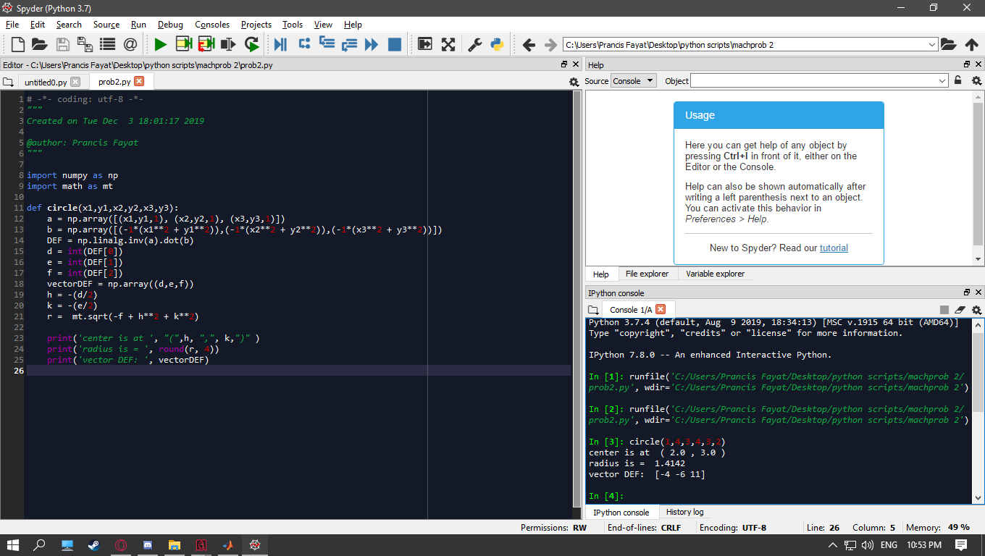

test using desmos graphing calculator:

From vector [D,E,F] the general equation is x^2 + y^2 – 4x – 6y + 11 – 0

